**GoTo Meeting Class Connection Instructions**

**HOW TO *JOIN* A MEETING**

1. **Turn on computer, power button is located on right side of computer monitor.**
2. **If another user has used machine, click on the “Switch User” button.**
3. **Log in as NON-BCC account:**
   1. **Log in as Instructor, the username is instructor: Password (leave blank and hit Enter)**

**Username: machine name of classroom\instructor**

**Password: Hit Enter**

1. **In the lower right hand corner of the desktop screen, there is a block arrow.** 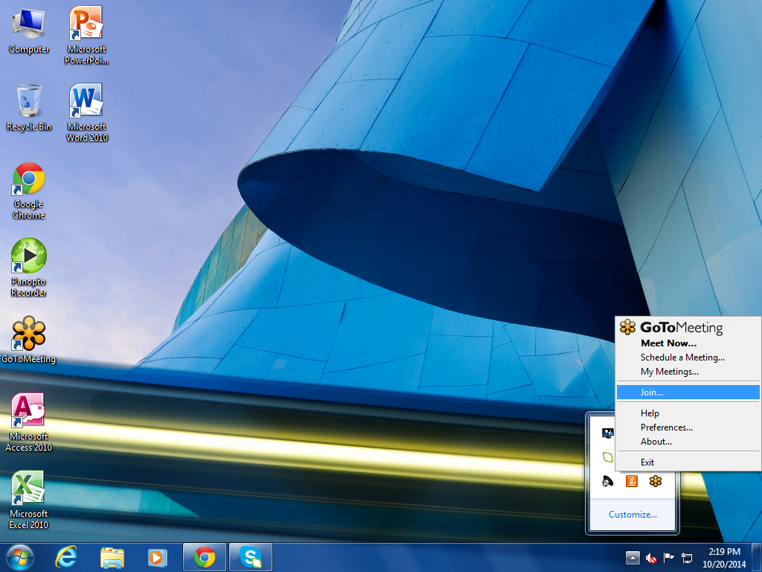
   1. **LEFT click on the block arrow.**
      1. **A box will pop up**

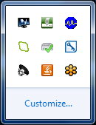

* + 1. **RIGHT Click on the Orange Flower Icon.** 
  1. **A box list will pop up, LEFT Click on Join…**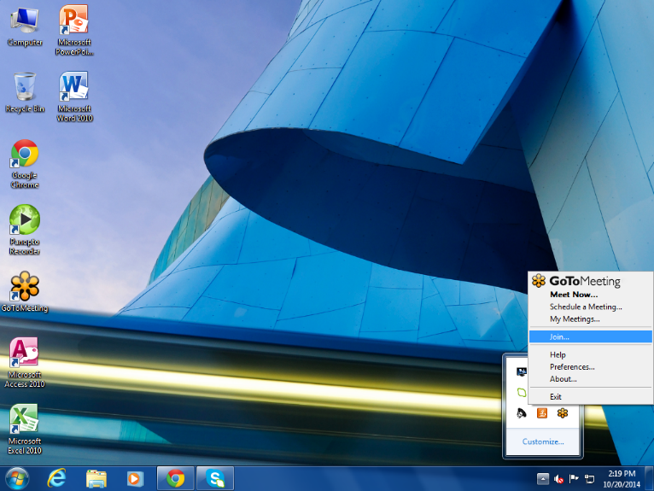
  2. **A Join Session box will pop up, enter the meeting ID number and press the “Enter” key.**

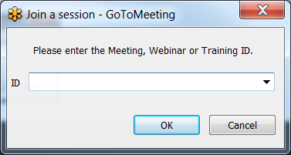

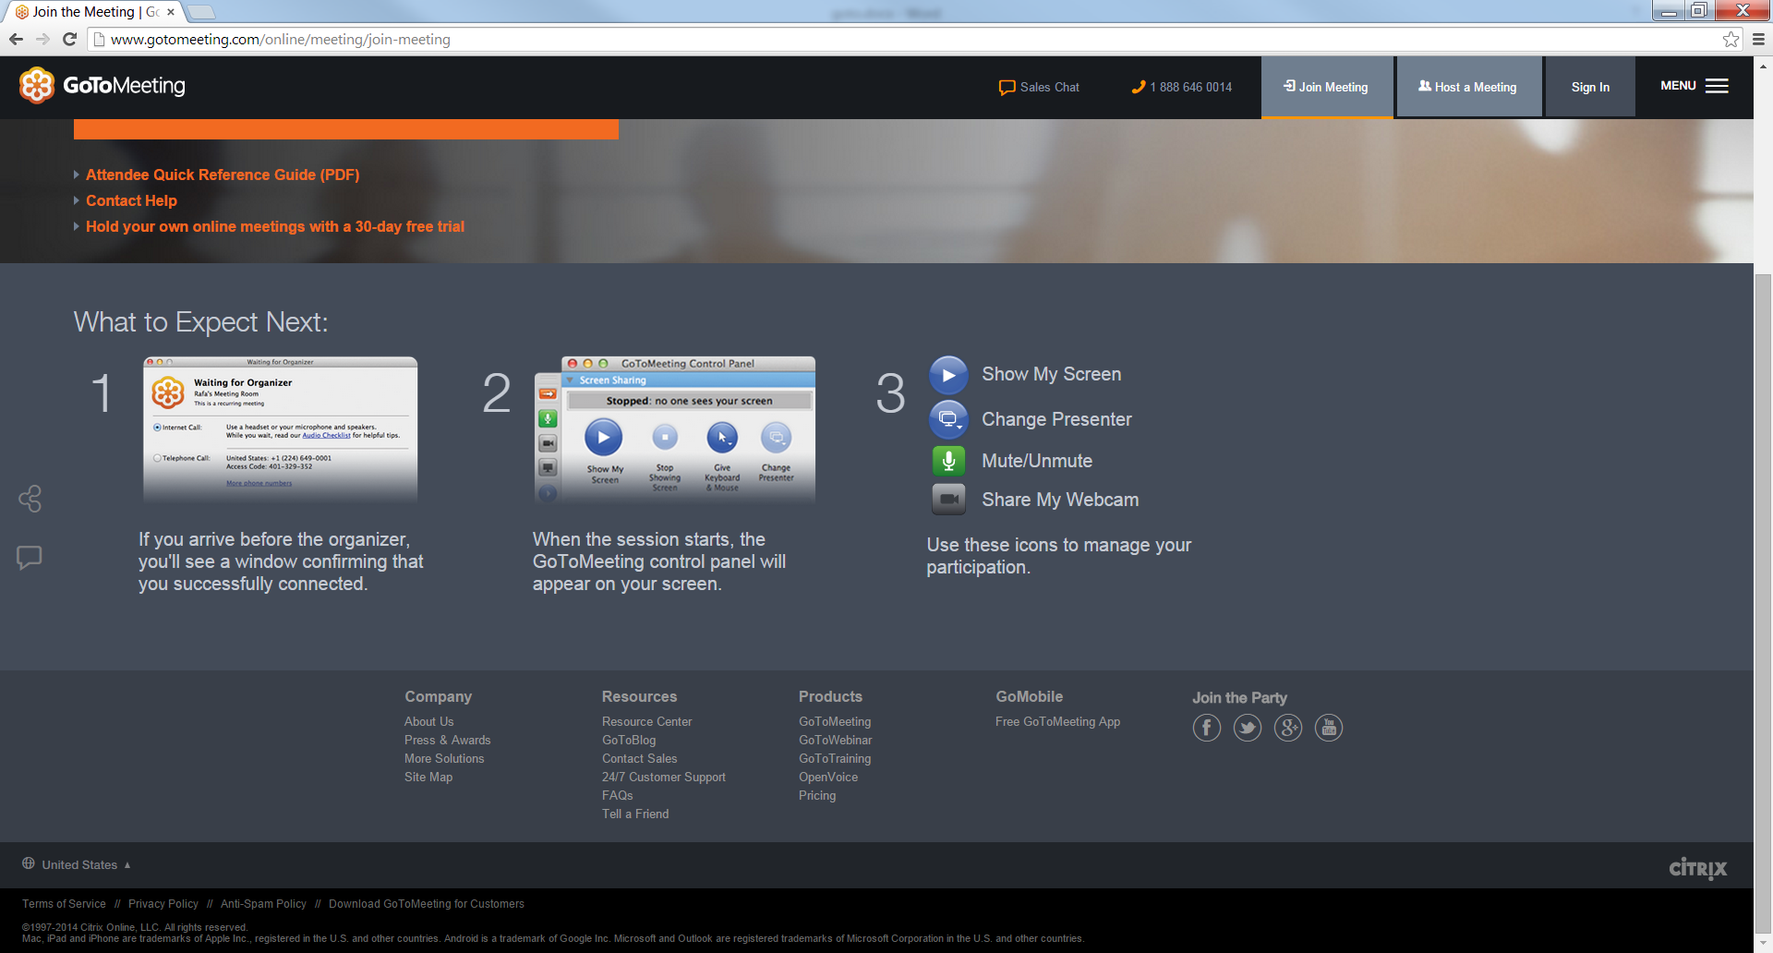

1. **Be sure that the speakers are set apart and the camera is set to view the you/students in the class room.**
2. **For further assistance with GoToMeeting please Call HELP DESK at ext. 100**