Open Power bi Desktop

Get Data

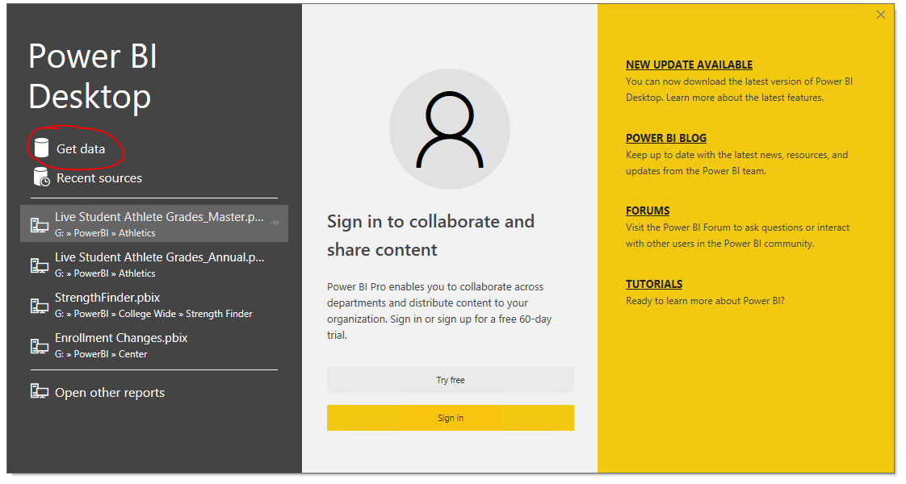

Excel

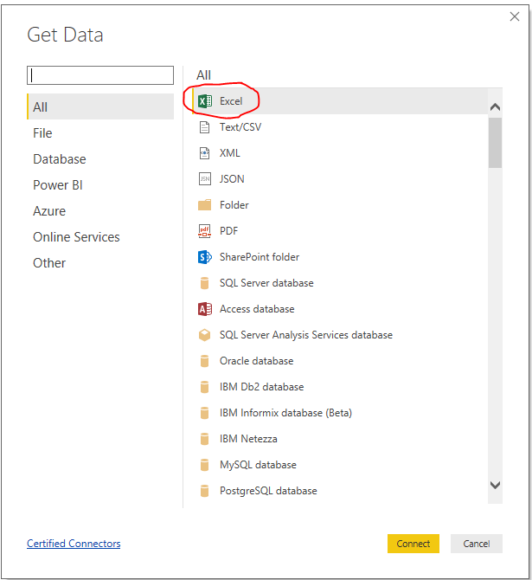

Navigate to excel file location and select file

Select correct spreadsheet tabs to load

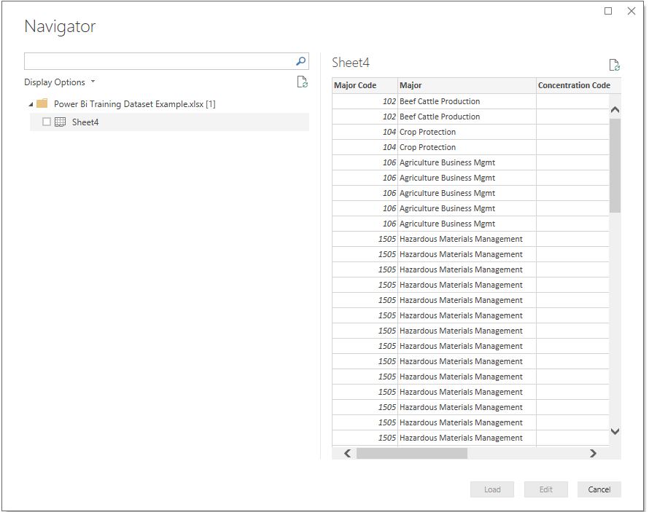

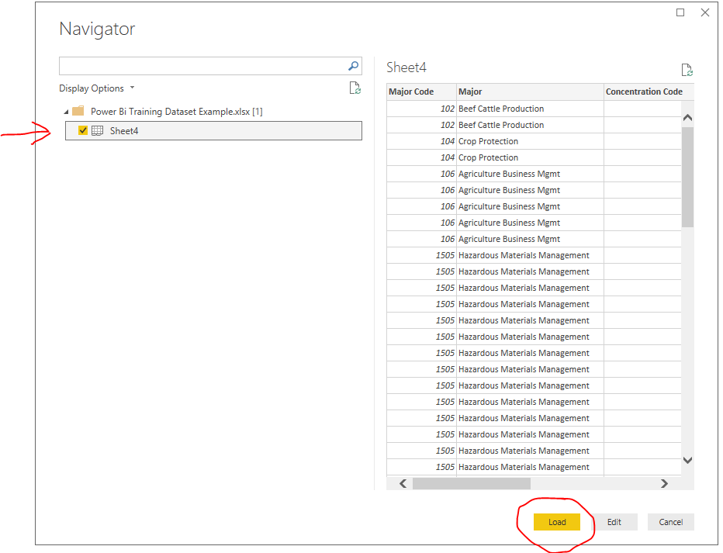

Once loaded you should see this:

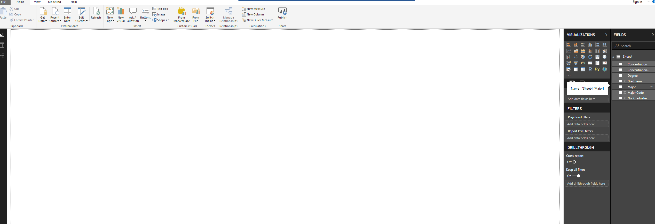

Drag Grad Term to white area to start designing