Title: Power BI “The Frosting on your Data.”

Ray Willis
Charles Perkins

Overview: When was the last time you enjoyed producing a data report and also felt confident the report was easily readable? Barton has been on a 6-year journey to transform how we deliver data and also keep our jobs enjoyable and meaningful. This transformation had to: require very little college funds, be sustainable, visually engaging, exportable to Excel, live from Ellucian Banner, static from Ellucian Banner (daily/hourly updates), static from Excel, easily updateable from excel, sort of live from Canvas Learning Management System, able to be published to Web, fine grained security, able to have indexes, work on mobile devices, etc. Microsoft Power BI has been able to meet all of these criteria. Currently we have about 100 users of internal reports at a cost of just over $2,000 per year. Web users are no cost.

In this ½ day learning experience we will take someone from beginner to publisher.
- Overview
- Power BI Desktop
- Connecting to data sources
- Power BI Web
- Clean and transform data with Query Editor
- Manage data relationships
- Create and customize simple visualizations
- Slicers and tables
- Exporting data
- Dashboards and Apps
- Publishing and sharing
- Gateways and refreshing data

Outcomes:
- Understanding of how Power BI could integrate into their college reporting environment
- Understanding of live and static data feeds
- Understanding of the different types of data gateways.

Books and other reference materials.

https://radacad.com/online-book-power-bi-from-rookie-to-rockstar

- Overview
  - Show Live Enrollments, Frequently Requested Data, Power BI Tips, Users Viewing Power BI Reports and Dashboard.
- Download and install Power BI Desktop (Windows Only)
  - Discuss using a shared drive to store .PBIX files and departmental desktop/Office 365 account to publish to the web. Must have Power BI Pro License.
    - Discuss folder/file names – layout the same as Apps.
    - Discuss page naming.
    - 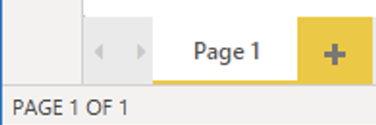
    - Discuss documentation.
  - Open Power BI Desktop and highlight parts.
    - 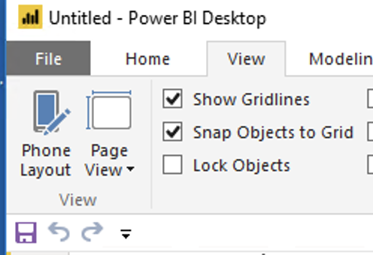
    - 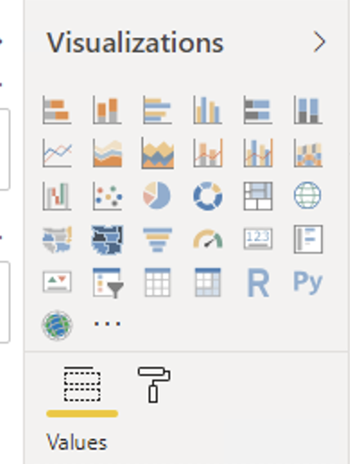

  - Discuss Bookmarks, Clear All Slicers Button, layout of filters/data, formatting, and colors.
    - Recommend that you do not change fonts or page size.
  - Discuss how to setup a spreadsheet properly.
    - Discuss whether to use a spreadsheet or put data in Power BI.
    - Spreadsheet names should match visualizations
    - Tab name(s)
    - Table name(s)
    - Where to save the spreadsheet.
      - One Drive or Shared drive.
      - One Drive allows for automatic updates
- Power BI Web Editor
  - Works completely from the web.
  - We recommend that you never edit a report you created in Power BI Desktop with the web editor as the reports will be out of sync.
  - Cannot import a graphic.
- Connecting to data sources.
    - Lots of options we use direct connect to Excel, Microsoft ODBC and Amazon Redshift.
    - Discuss shared account for database rights.
    - Be sure to pay attention to credential window when connecting to database and click on the appropriate selection, Windows or Database.
- Clean and transform data with Query Editor.
  - Limit the amount of data you import. Choose only the columns you need and apply any filters you can right off the bat, BEFORE merging with other queries.
  - Query editor sometime “helps” you by changing the data format.
  - Some data preparation options work only in import mode, not in direct query. Often you can find a different method to accomplish the same thing in direct query.
  - The Advanced Editor can be very helpful as it allows you to directly view/edit the code used in your query.
  - Any table/query not directly used in a visual can have Enable Load unchecked to use less memory while still passing data to other queries as needed.
- Manage data relationships
  - Be sure to check relationships as Power BI “helps” you by creating some automatically.
  - You can select File\Options and Settings\Options\Data Load to turn off automatic creation of relationships. Must be done in each report as setting it once doesn’t apply to new reports.
  - You will need to create a unique key to use in relationships as you cannot join on multiple fields. (Note that this is different than merging queries in the Query Editor as multiple fields can be joined there.)
  - By default, Power BI will establish relationships with a Cross filter direction of Single that may need to be changed to Both for slicers and visuals to function as desired.
- Create and customize simple visualizations
  - Download example spreadsheet. https://docs.bartonccc.edu/research/powerbi/MidAIR/MidAIR%20NCCBP.xlsx
  - Slicers and tables
  - Be careful of random clicks
- Exporting data
  - You decide if users can export data to Excel.
- Dashboard and Apps
  - Dashboards cannot be published to the web.
  - Apps have indexes and can be organized by department: Administration, President, Instruction, College Wide, Student Services, etc.
  - 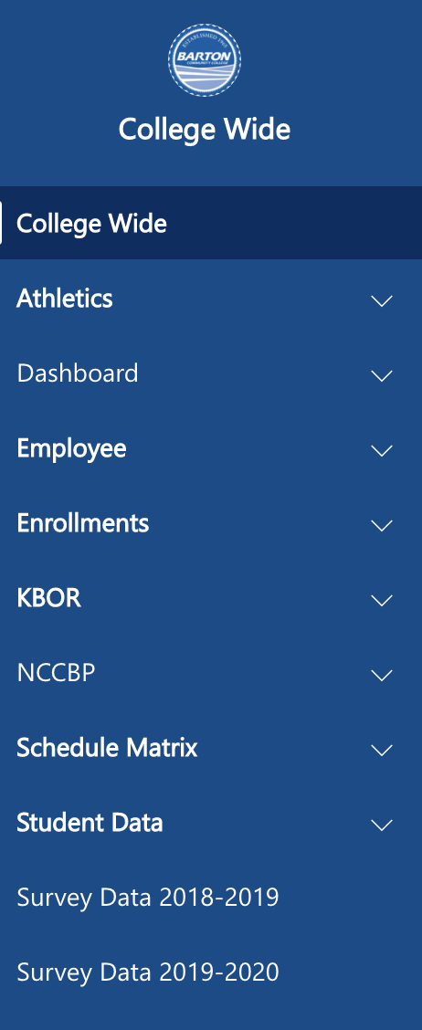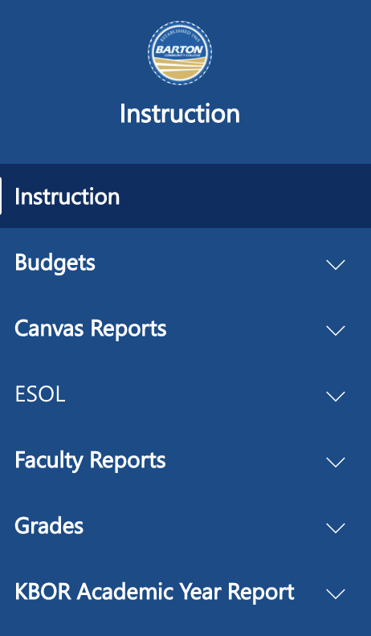
- Publishing and sharing.
  - Power BI does have a mobile App.
  - 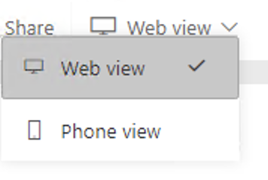
  - Put .PBIX on a shared drive.
  - Publish from Power BI Desktop to workspace
    - Discuss folder-file-workspace-App naming
  - Publish from Workspace to the Web.
  - Sharing App
    - If reports are in the (On Off Button) App then all shared automatically when you share the App.
    - 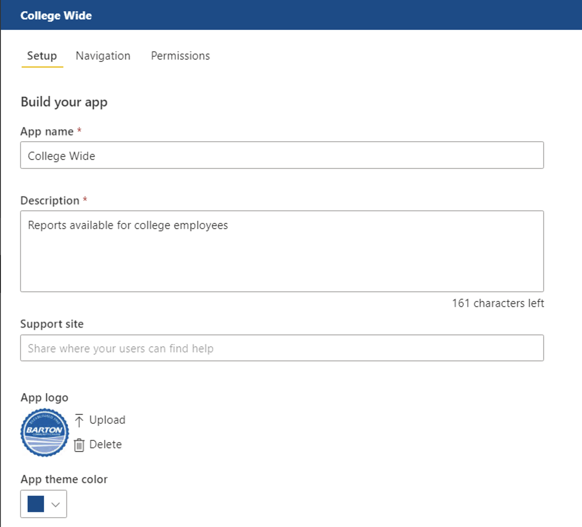
    - 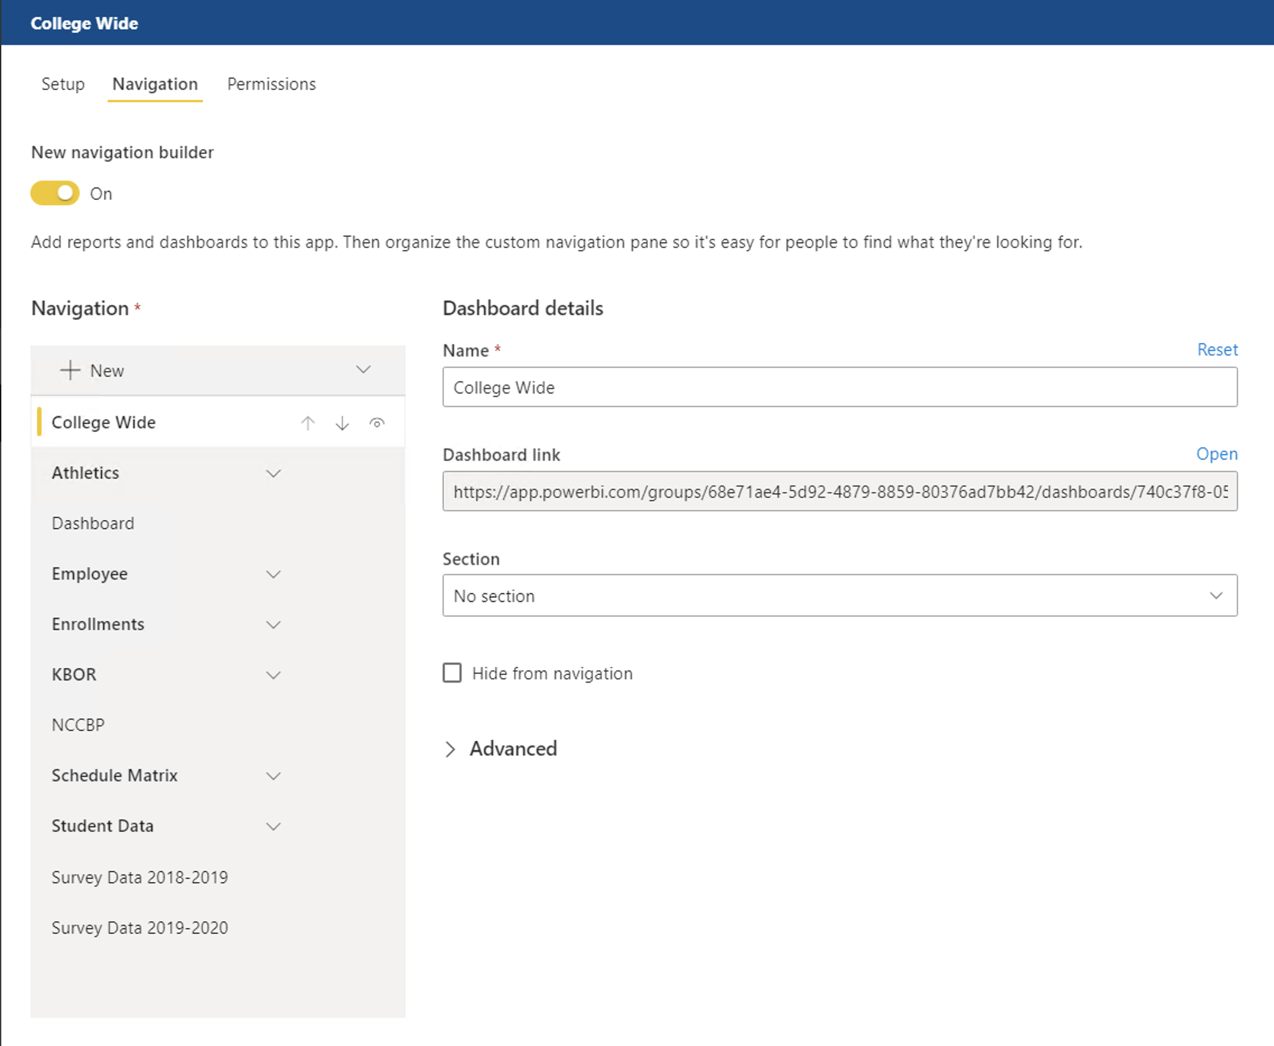
    - Subscribing to a report
    - Report usage metrics
      - Do not work with Apps
- Gateways and refreshing data.
  - Gateways are on-premises.
  - Gateways connect reports published to Workspaces to their data sources.
  - Files in One Drive do not use Gateways.
  - Power BI Gateway software is at no cost.
  - You can use Personal Gateways if you do not have administrative access to your PC.
  - We have 2 gateways.
    - One for live data feeds from ODBC sources. Windows Server.
    - One for connecting to local files on C: drive and live data feeds. Shared Desktop.
  - Gateways are found by clicking on the Gear.
  - 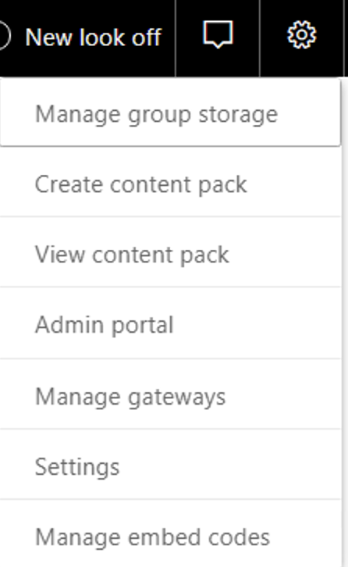
  - Gateways are straight forward to configure and test.
  - 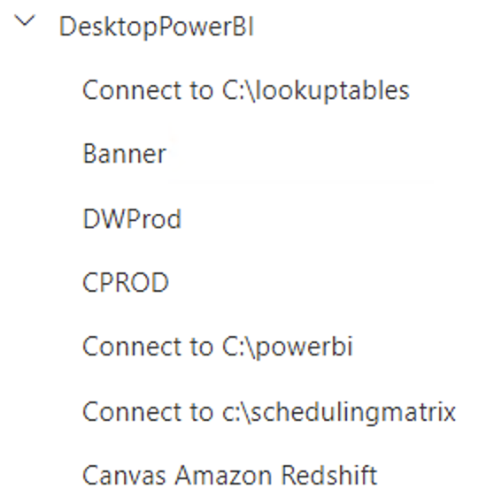
  - 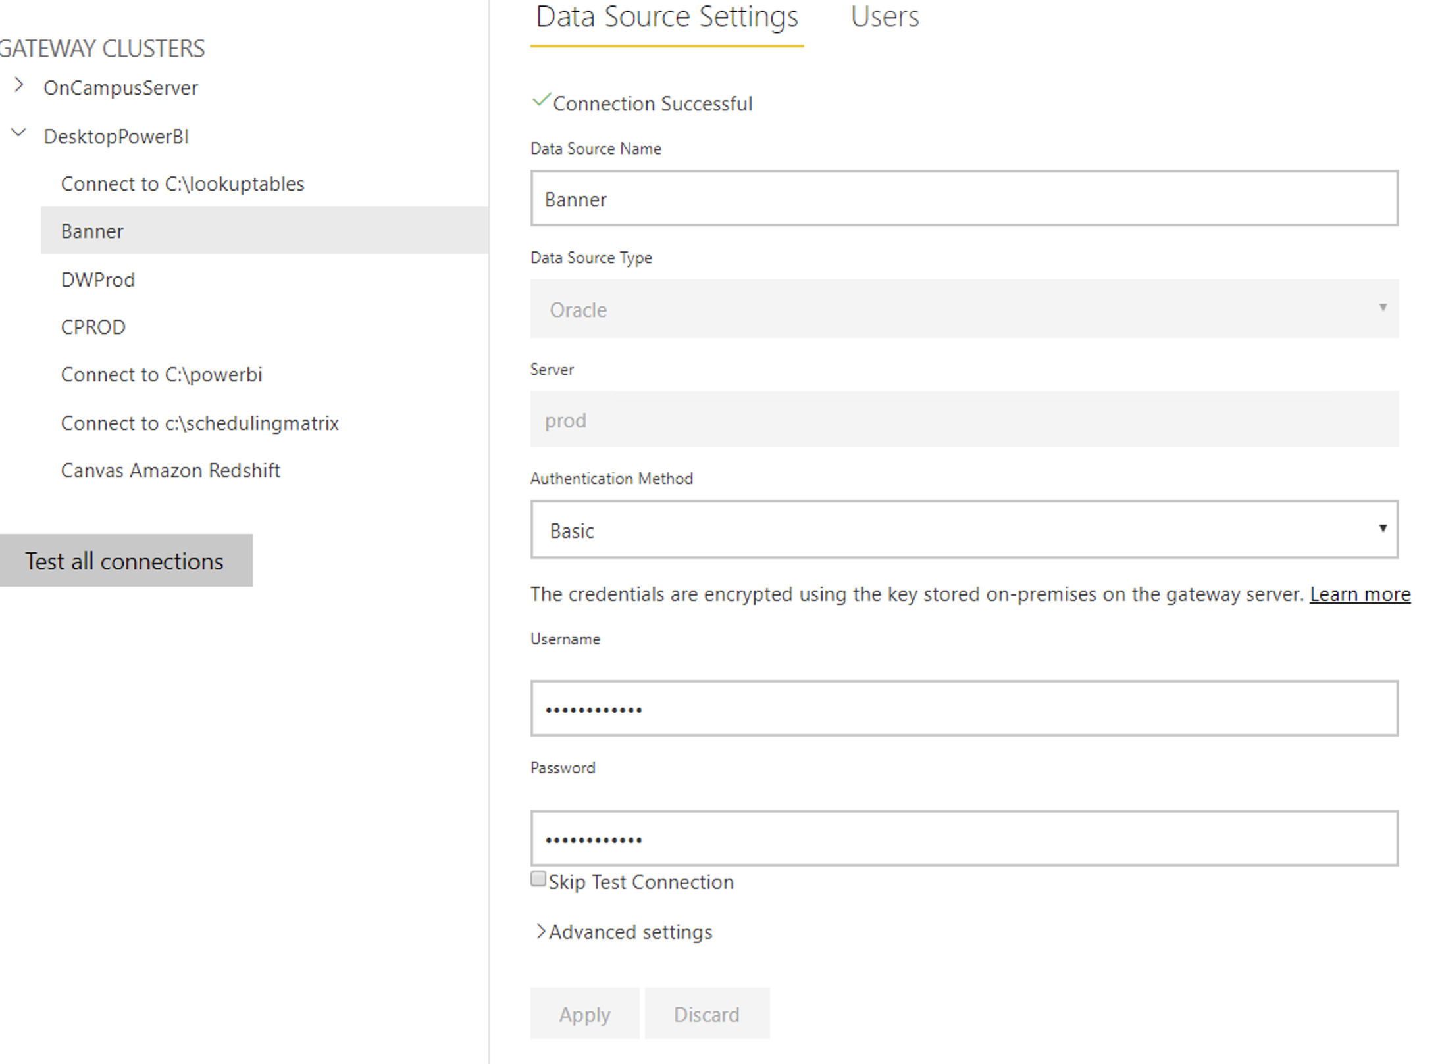
  - You can add users to your gateway.
  - 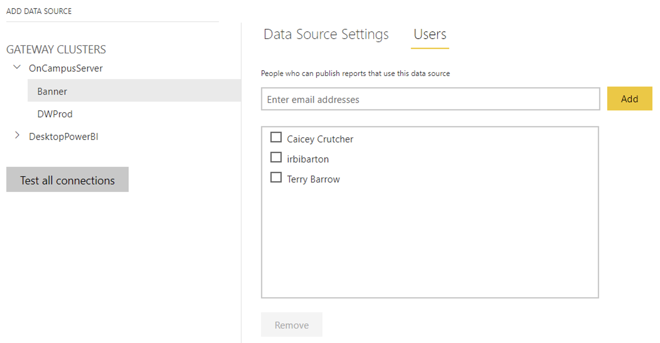
  - Gateway needs to be configured before you publish a report which needs it then the report will autoconfigure itself to the gateway. If you can add the gateway manually.
  - 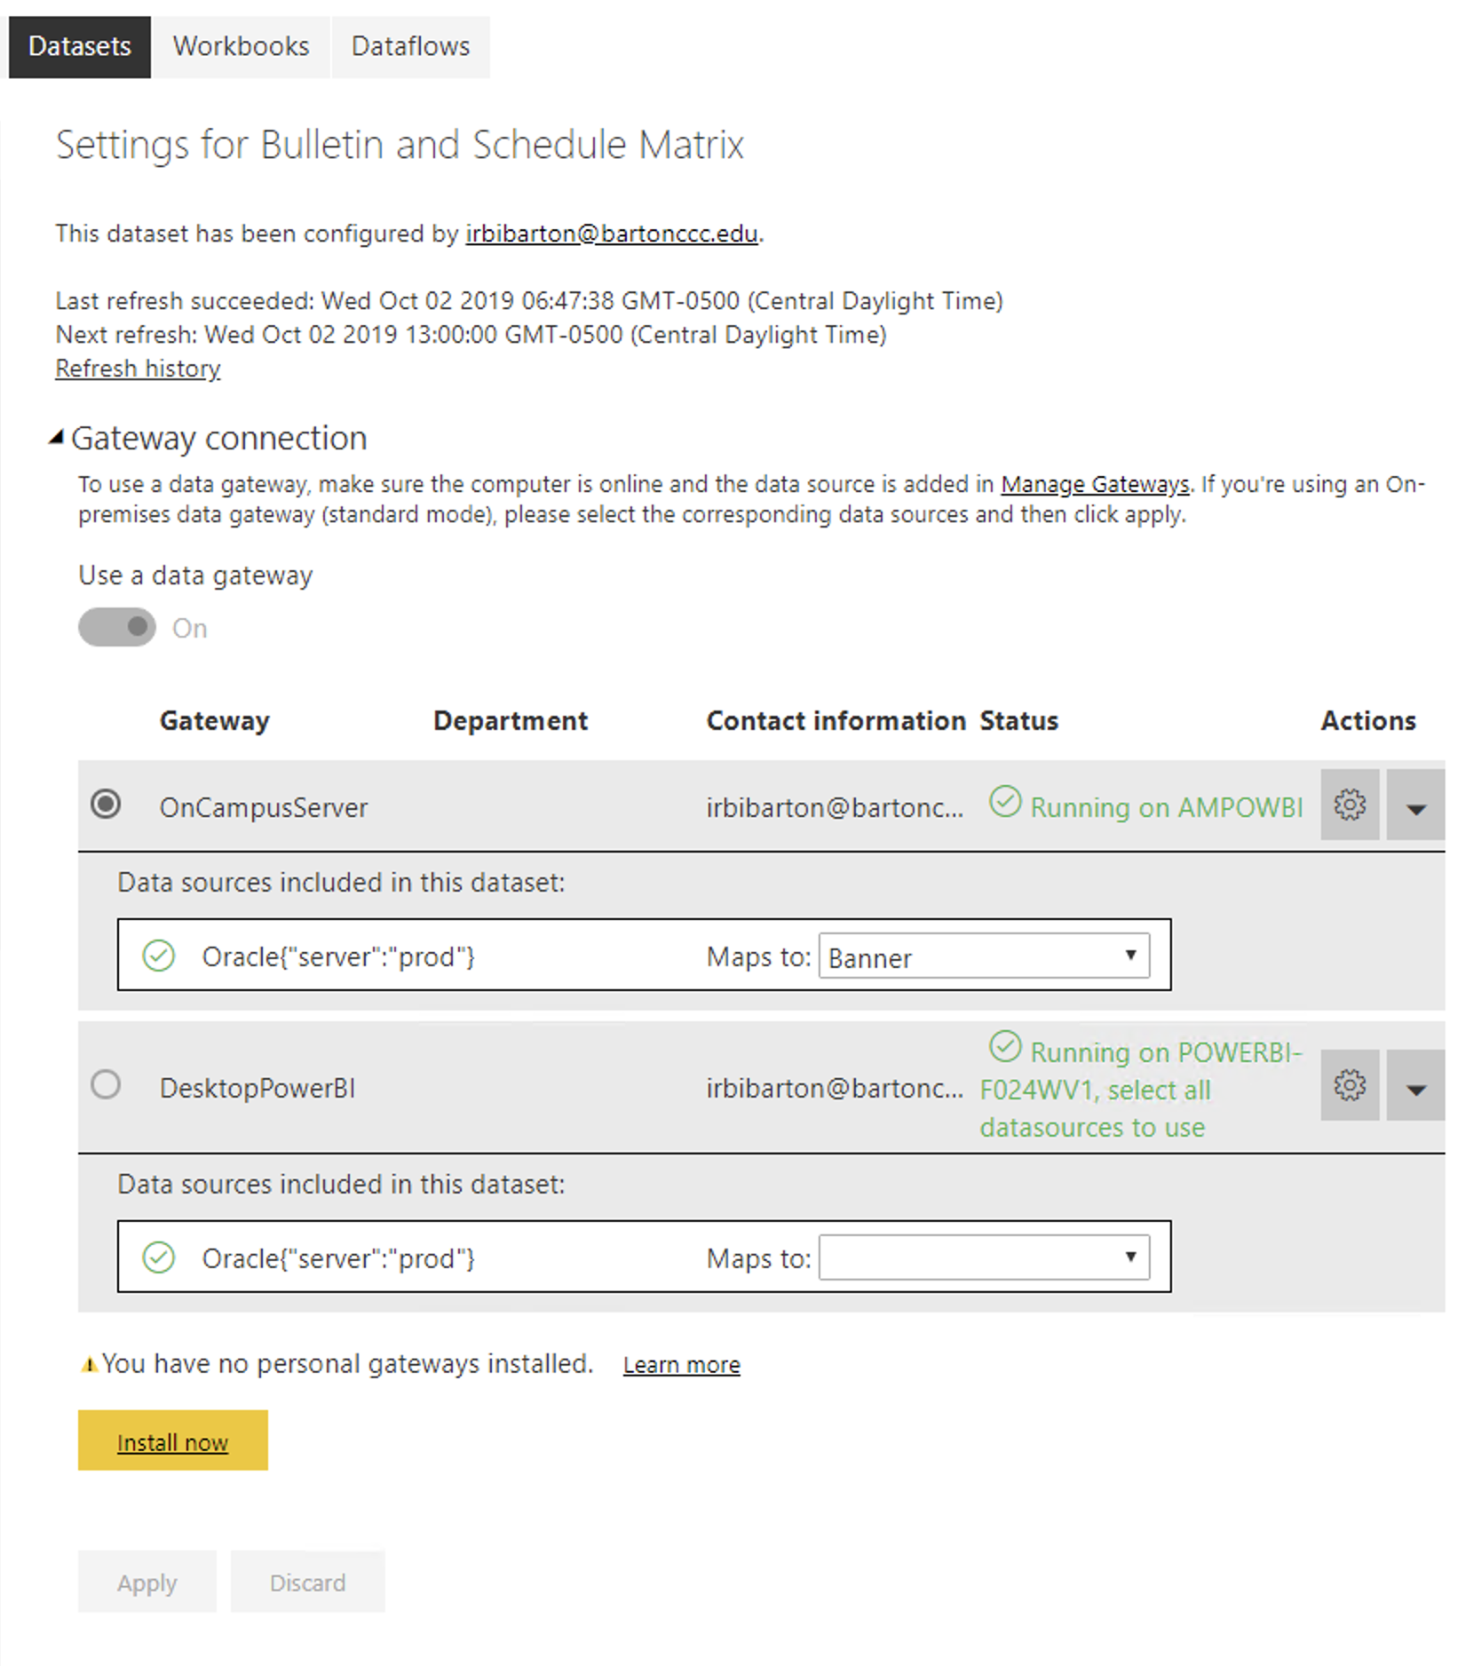
  - Hidden 3 dots to add connectors
  - 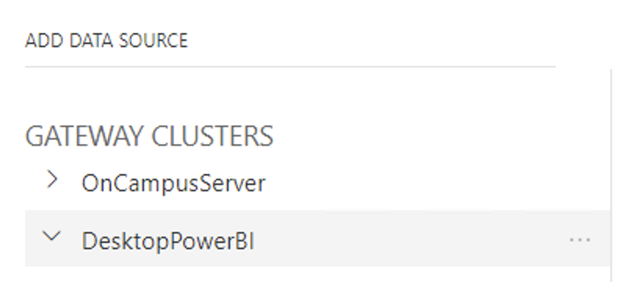
  - Some reports will need to be scheduled to update.
  - 