Current Openings: CNC II
Mig Welder
Engine Lathe II

Custom manufactured hydraulic cylinders provide daily challenges at an industry leader with solid performance since 1967. The company provides a competitive base wage and benefits package including 11 paid holidays, 2 weeks vacation after 12 months service, 401k with 25% match, and support for continuing education opportunities.

Must be able to read and understand written instructions, blueprints, and precision measuring equipment, and complete accurate calculations using shop math. Additional on the job paid training provided by the company on day shift. CNC II and Mig Welder will train on days 7:00am-3:30pm weekdays before going to evening shift 3:30pm-12:00am weekdays. Engine Lathe II is a first shift position.

What are you waiting for?
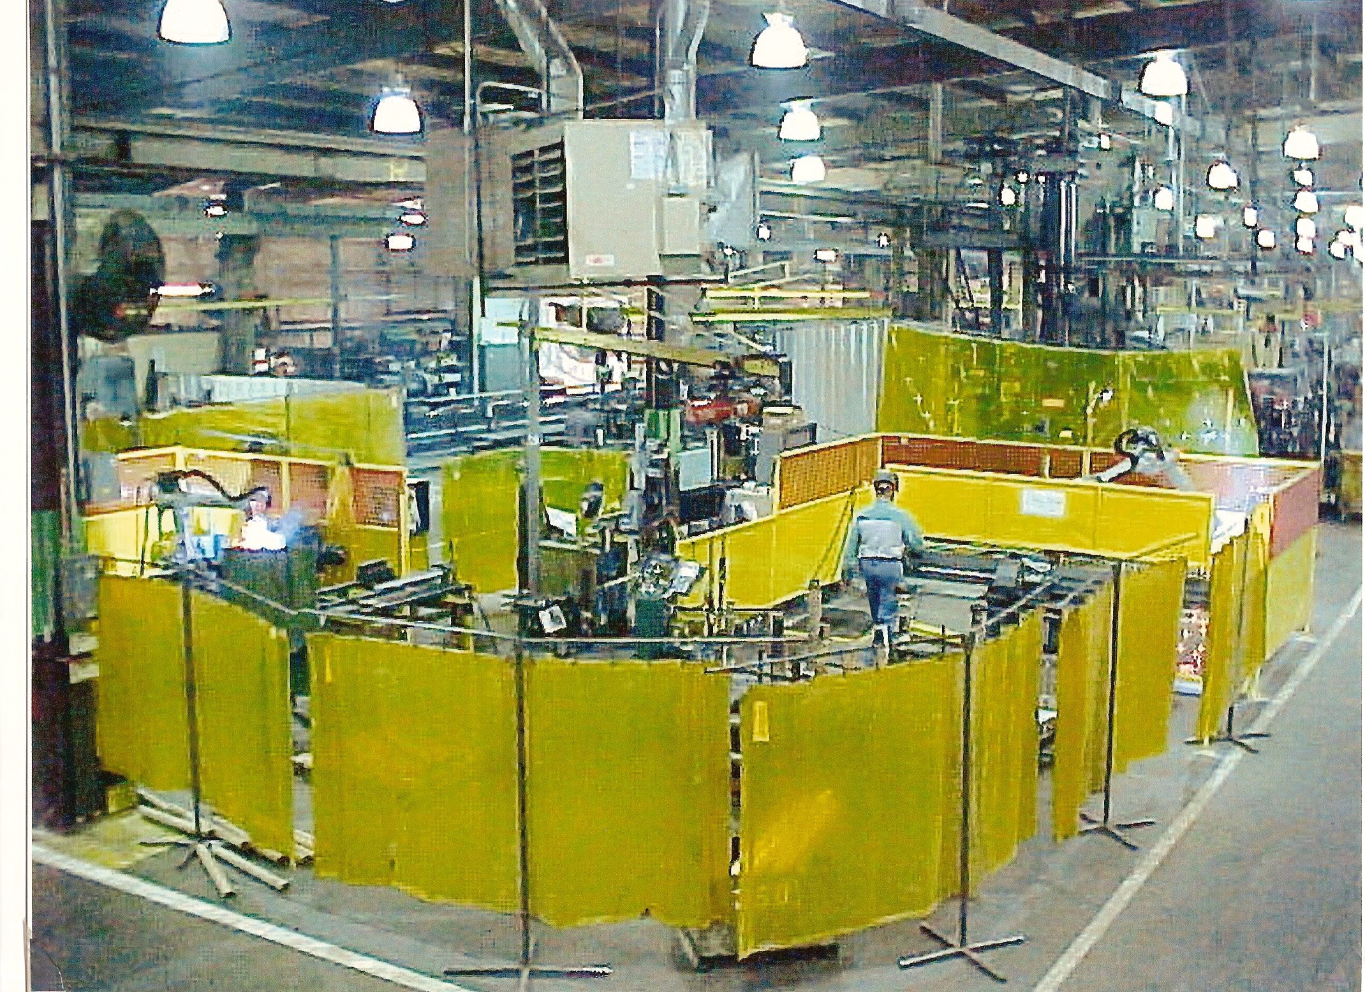
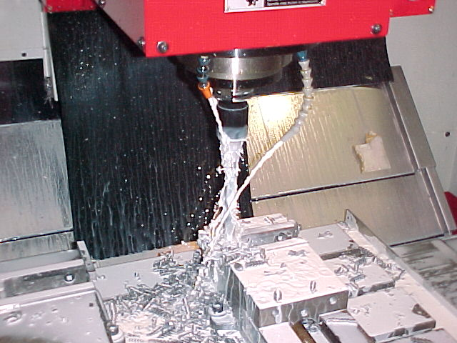
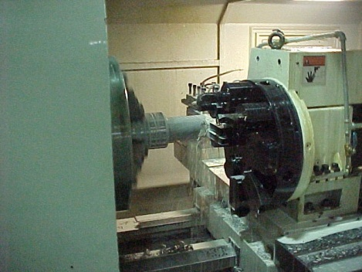

Qualified candidates may call: Human Resources at (620) 792-4368 Extension 415 or email resume to twest@greatbendindustries.com.

Great Bend Industries is an Equal Opportunity Employer. Great Products! Great Service! Great People!

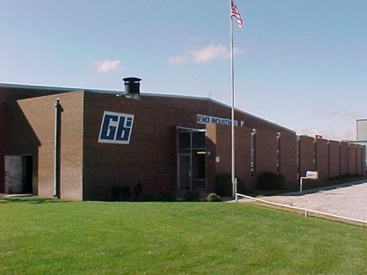
Great Bend Industries / 8701 Sixth St. / Great Bend, KS 67530
For additional info on our company: http://www.greatbendindustries.com/

