Ticks and Lyme Disease
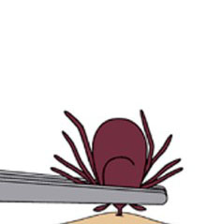
Recent news reports indicate this may be an extremely bad year for lyme disease due to tick bites. To the right, are web sites providing information conserning what to look for and preventative measures you can take.
It often takes several hours for a tick to transmit Lyme. Remember if you should get a tick, follow recommendations closely for removal. You want to be sure and get the head. It is also recommended you place the tick in a container and freeze it. If you should develop symptoms later, you can take the tick immediately to the doctor and for determination if the tick was a carrier of lyme disease. This will enable you to start your treatment promptly with no delays.
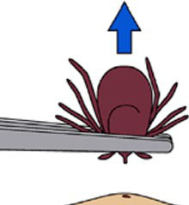
________________________________________________
If you find a tick attached to your skin, there's no need to panic. There are several tick removal devices on the market, but a plain set of fine-tipped tweezers will remove a tick quite effectively.
How to remove a tick:
- Use fine-tipped tweezers to grasp the tick as close to the skin's surface as possible.
- Pull upward with steady, even pressure. Don't twist or jerk the tick; this can cause the mouth-parts to break off and remain in the skin. If this happens, remove the mouth-parts with tweezers. If you are unable to remove the mouth easily with clean tweezers, leave it alone and let the skin heal.
- After removing the tick, thoroughly clean the bite area and your hands with rubbing alcohol, an iodine scrub, or soap and water.
Avoid folklore remedies such as "painting" the tick with nail polish or petroleum jelly, or using heat to make the tick detach from the skin. Your goal is to remove the tick as quickly as possible--not waiting for it to detach.
The Lyme Disease Association adds these tips:
Remove an attached tick by sliding something under it, such as a credit card or tick remover. Lift the tick up until the person’s skin is puckered, and wait a minute for the tick to release itself. If it doesn’t pull out, go ahead and lift it out with the remover or tweezers.
Large ticks may be removed with fine-pointed tweezers, but don’t squeeze the tick’s belly or Lyme germs from the tick’s guts may squirt into you. Don’t use a hot match, petroleum jelly, liquid soap, nail polish, rubbing alcohol or other chemicals, or the tick may vomit germs into you before it pulls itself out, making illness more likely. After removing the tick, disinfect the bite site, removal tool and your hands.
American Lyme
Disease Foundation
Canadian Lyme
Disease Foundation
CDC - Lyme disease
Lyme Disease Association

