September 2020 POLICY TYPE: ENDS
POLICY TITLE: ESSENTIAL SKILLS

Students will acquire the skills needed to be successful for the program they are in.
- Students will have the essential skills to succeed in the workplace.
- Students will have the essential skills to lead productive lives.
- Students will be provided remediation as needed.

Indicator #1: Students will have the essential skills to succeed in the workplace.

ADULT EDUCATION
One of the first steps to success in the workplace is the attainment of a Kansas State High School Diploma. This credential is recognized as key to employment opportunities, advancement, further educational options and financial incentives.

According to the Lumina Foundation’s study, “A Stronger Nation”, by 2025, 60 percent of Americans will need some type of high-quality credential beyond high school. Kansas' attainment rate is 52 percent, and the state is working toward its attainment goal of 60 percent by 2020.

Barton offers access to instruction that leads individuals to prepare and potentially earn their Kansas State High School diploma. Students working towards this outcome take the General Educational Development (GED) test.

Presentation: Coordinator of Adult Education - Matt Connell

Center for Adult Education

Indicator #2: Students will have the essential skills to lead productive lives.
Presenter Jo Harrington
Completion of a Barton Community College degree template will enable students to:
Fundamental Outcome 1: Critical Thinking
Study a given subject critically, including processes to analyze and synthesize important parts of the subject, to ask appropriate and useful questions about the study of this subject, and to solve problems within the subject area.
Fundamental Outcome 2: Life-Long Learning
Relate the relevance of a given subject to the individual student’s life, to develop habits that encourage life-long, responsible, and independent learning, and to apply appropriate and useful knowledge of the values, conventions, and institutions within an academic discipline.
Fundamental Outcome 3: Historical Perspective
Describe how history works, including how historical perspective can strengthen understanding of a given academic subject, and how the history of human endeavor has helped develop that subject.
Fundamental Outcome 4: Technological Perspective
Explain how technologies affect important parts of human life and how information technologies shape the study of a given subject.
Fundamental Outcome 5: Cultural Perspective
Explain how culture develops through various aspects of human endeavor, how culture develops understanding of a given subject, and how a given subject develops within different cultures.
Assessment of the fundamental outcomes will serve as an indicator of the essential skills retained by our students and their ability to lead productive lives. To allow for a detailed explanation of the data, the Institutional Assessment data will be presented one at a time rotating each year.
This year, we will discuss fundamental outcome three. This outcome again deals with the expectation that students can describe how historical perspective can strengthen the understanding of a given academic subject, and how the history of human endeavor has helped develop that subject. Assessing the fundamental outcomes takes advantage of the course assessments in place at Barton. Course assessments ask faculty to assess the competencies or learning objectives of their courses.
A benchmark of 70% is used and as shown, all fundamental outcomes are currently above this mark for 2020.
Percentage of correct responses on outcome/course assessments
Outcome | 2016 | 2017 | 2018 | 2019 | 2020
F-1 | 83% | 81% | 76% | 81% | 79%
F-2 | 77% | 76% | 76% | 64% | 72%
F-3 | 79% | 75% | 71% | 73% | 73%
F-4 | 76% | 78% | 82% | 84% | 82%
F-5 | 77% | 77% | 80% | 80% | 76%
OVERALL | 79% | 78% | 76% | 75% | 76%
*Data up-to-date as of 08/10/2020

Indicator #3: Students will be provided remediation as needed.
Presenter: Brian Howe/Carol Murphy
Developmental Monitoring Report
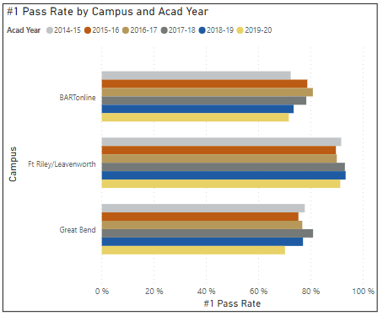
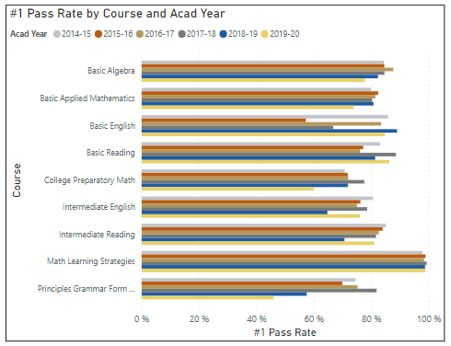

Developmental Monitoring College Ready
